Assessing embodied carbon emissions of communication user devices by
combining approaches

Nina Lövehagen¹, Jens Malmodin¹, Pernilla Bergmark^{2*}, Sepideh Matinfar¹
¹ Ericsson Research, Ericsson AB, 16483 Stockholm, Sweden
² World Benchmarking Alliance, *employed at Ericsson AB when main study was performed
The use of information and communication technologies are increasing in society. Carbon emissions can be found throughout the entire life cycle of access networks, data centers and communication user devices. The focus of this study is the embodied carbon emissions taking place before the use of user devices associated with accessing networks, hence tablets, smartphones and feature phones, laptop and desktop PCs, PC displays and customer premises equipment (CPEs).
The purpose is to investigate the embodied carbon emissions by applying different approaches: i) the commonly used approach where estimated product carbon emissions are scaled up by shipments, ii) allocation of the electronic sector companies’ reported data combined with materials data for the products, and iii) the upstream carbon emissions reported by user device vendors (final manufacturers). Despite its sensitivity to allocation the second approach is considered to give the most reasonable overall result of about 180 million metric ton carbon dioxide equivalents (Mt CO₂e) related to chosen user device types and shipments in 2020¹. Underreporting of scope 3 in the data sources of the vendors, and sensitivity to specific product data sets with very high display values are two major concerns of the other approaches. Representative embodied emissions for user devices are derived for 2020¹: 50 kg CO₂e for a smartphone, 20 kg CO₂e for a feature phone, 100 kg CO₂e for a tablet, 200 kg CO₂e for a laptop, 350 kg CO₂e for a desktop PC, 100 kg CO₂e for a PC display and 30 kg CO₂e for a CPE.
Data for 2024 indicate a total of about 150 Mt CO₂e and that the representative values should be lowered by about 10% for smartphones and tablets and PCs.

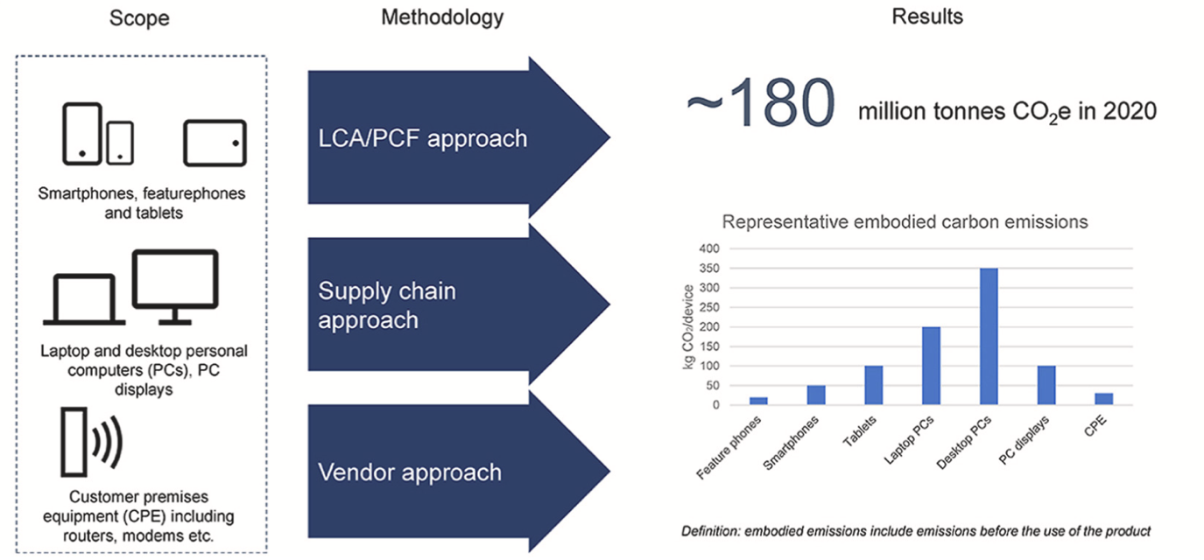
[1] Lövehagen, N., Malmodin, J., Bergmark, P., & Matinfar, S. Assessing embodied carbon emissions of communication user devices by combining approaches. Renewable Sustainable Energy Rev., 2023, 183, 113422.
[2] Malmodin, J., Lövehagen, N., Dahl, T., Lundén, D., Frantz Schneider, A. ICT sector electricity consumption, GHG emissions, and other key figures – Development 2007 to 2024. Accepted for publication at ICT for Sustainability (ICT4S), Bern 8-12 June, 2026.

